**Steering conception**

**Vocabulary:**

* Cardan : U-Joint
* Colonne de direction : steering column
* Crémaillère : Steering rack
* Volant : steering wheel

**Goals :**

* Optimize tires grip in cornering.
* Offer satisfying driving experience regarding the steering wheel effort feedback.

**Conception steps**

1. Determination of optimum wheel angle thanks to a cornering model

Hypothesis:

* The tires are working at their maximum potential
* The car is cornering in steady state
* The camber change and tire pressure variation is not taken into account
* The center of gravity is estimated at 0.3m.

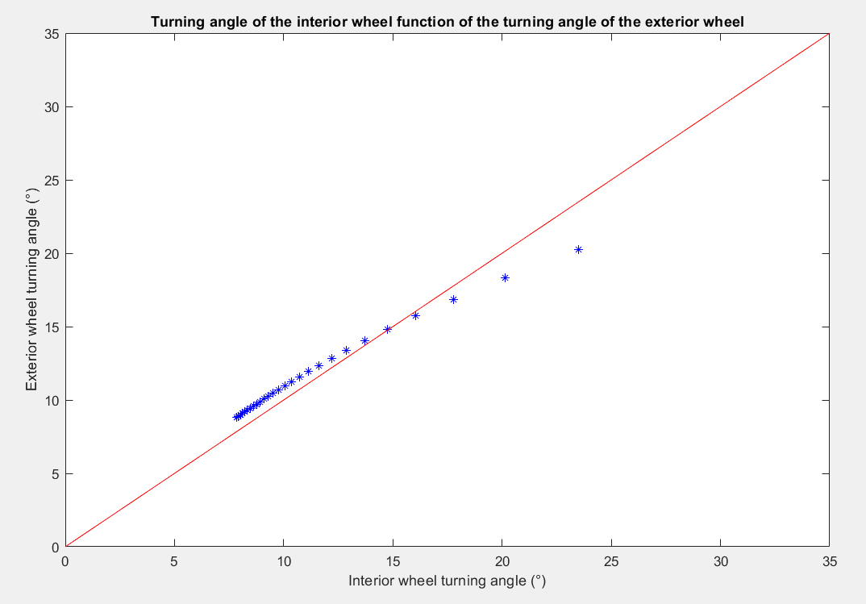

**Anti-Ackerman :**

Hight speed cornering in large corner.

**Ackerman :**

Low speed cornering in

tight corner.

**Skidpad**

The model gives a velocity of 12.4 m/s in skidpad hence a time of 4.9s.

1. Determination thanks to a 2D model of the real geometry fitting theoretical data

* View of the geometric model under geogebra

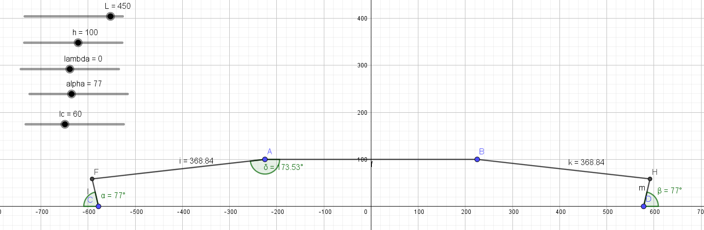

* Comparison between the 2D geometry et the theory

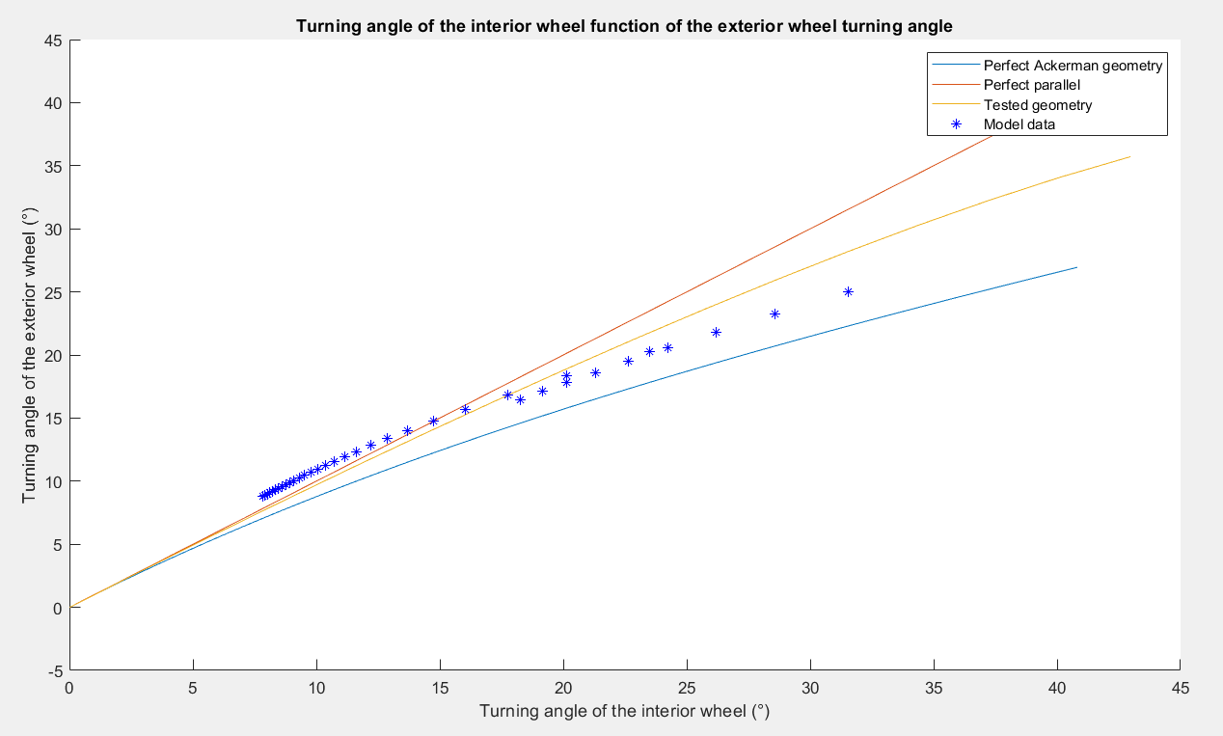

With a choice for an Ackerman type geometry to favor the skidpad.

1. Verification of the geometry thanks to a 3D model

* CATIA is used as 3D model

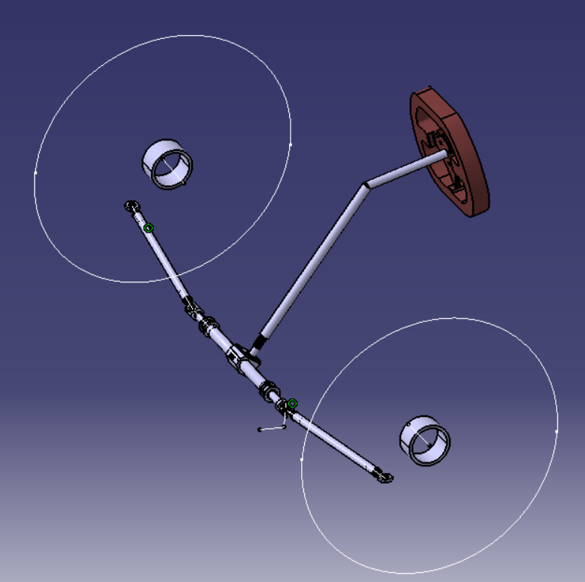

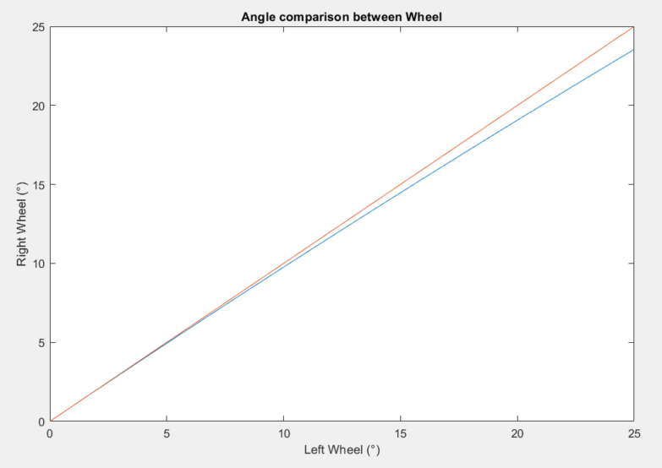

1. Bump steer adjustment

* Without any precise calculation, the geometry is set such that the bump steer is minimized.

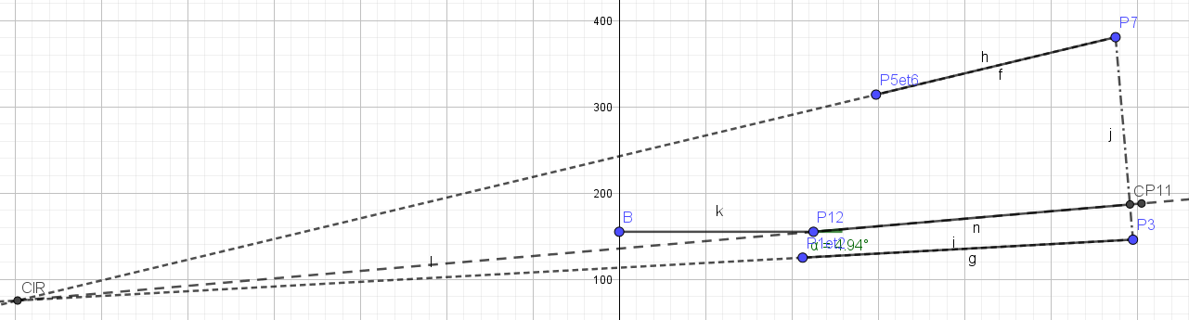

1. Castor trail determination

* Study on tire data to determine the castor trail necessary to have the maximum of grip at the maximum of self-aligning torque for different tire load and pressure.

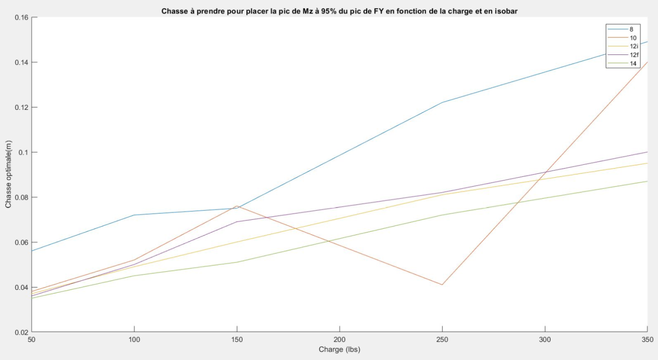

To ideal castor Trail is highly dependent on the tire load and pressure, hence it was decided to only use castor trail to tune the effort in the steering wheel.

1. Steering wheel effort feedback adjustment

The strength on the steering wheel was determined with a static model, the target value of 11.5N at 0° of input angle was chosen with the team experience.

Hypothesis:

* U-Joint efficiency of 1
* Static load case on the tire
* No lateral forces on the tire

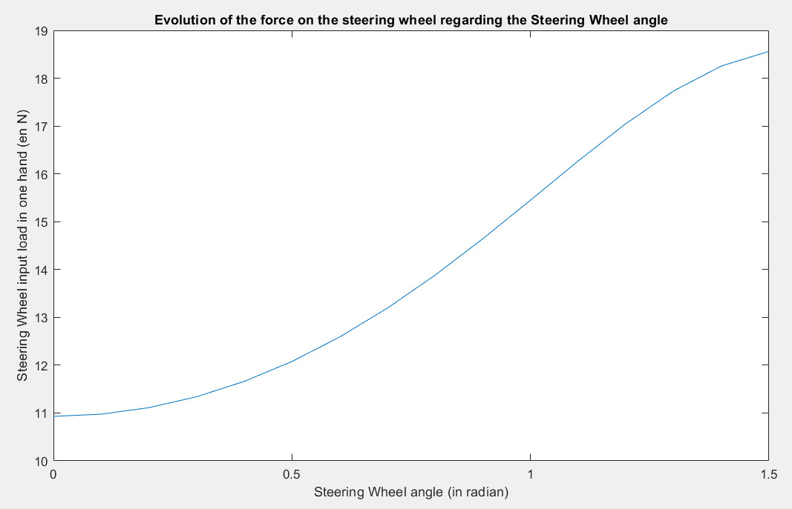

1. 3D conception

For the 3D conception, the load cases were:

* **100 N.m** of torque in the steering wheel
* **660N** of vertical load on the steering wheel
* **560N** of axial load on the steering linkage.

1. Comparison between the simulated geometry and the reality

